CE 5364 Groundwater Transport Phenomena June 24, 2020

MODFLOW/MODPATH/MT3D Project

Setting Up Flow Conditions

A plume of dissolved trichloroethylene has been found in a shallow unconfined aquifer. The distribution of the plume is shown on the figure on the following page. The shallow aquifer is the top of a three-layered system as shown in the figure below. An aquitard separates the unconfined aquifer from a lower leaky confined aquifer.

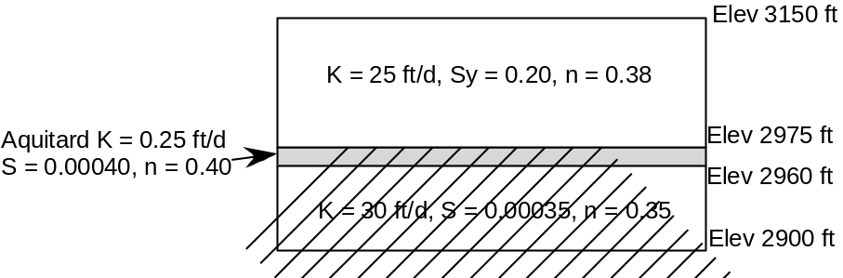

Three domestic wells exist down-gradient of the plume. Wells 1 and 3 are in the upper aquifer, while well 2 is in the lower aquifer. They each flow at 120 gpm.

Task 1. Set up the MODFLOW files and perform a steady-state run with representing the hydraulic conditions as described. That result will provide a initial head array for later runs.

Task 2. Use MODPATH to demonstrate the advective movement of the plume under the steady-state conditions. Consider particle transport in all 3 layers.

Transport with MT3D Tasks

Steady State Hydraulic Conditions

1. Advection and dispersion. Use MT3D with α_{L} = 10 ft and α_{T} = 1 ft and the initial concentrations properly distributed to show the movement of the plume and which pre-existing wells are impacted in terms of earliest and final plume contact. You may consider the leading and trailing edge of the plume to be represented by 5 or 1 ppb. Select one and be consistent.

2. Advection, dispersion, and sorption. Use a K_{d} = 0.20 along with the conditions in the previous task.
Demonstrate the plume’s impact on the existing wells similar to the previous task.

3. Find the necessary half-life with the conditions in problem 2 to prevent the plume from reaching the first pre-existing well.

4. Use extraction wells to remove the plume. You may use flow rates of 100 gpm or so.

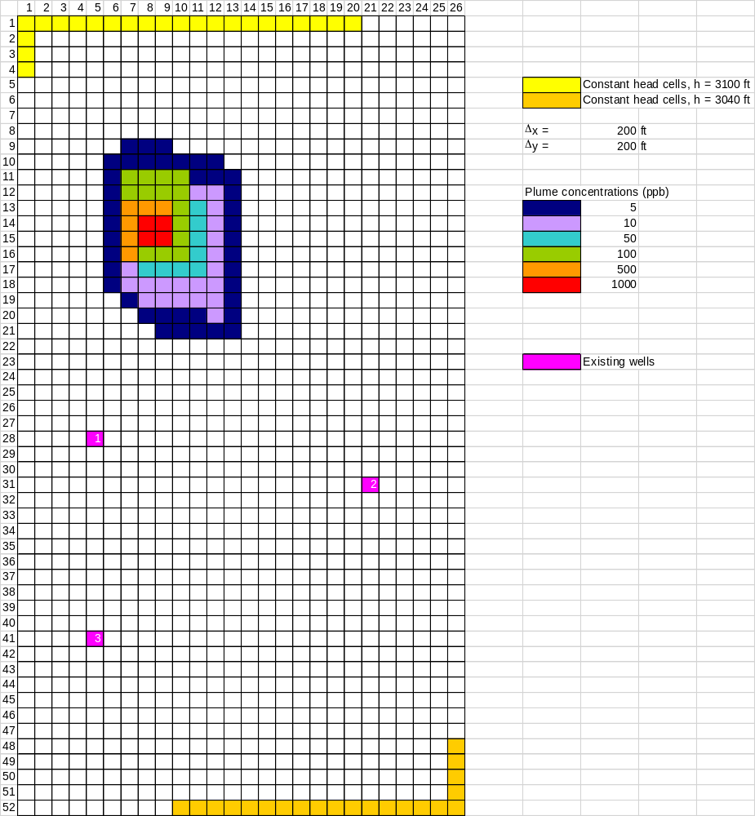

Report Requirements

A. General Description
Describe the general problem statement with the initial conditions. Provide a sketch or printout that shows the location and initial concentration values.

B. Specific Tasks
- Advection only. Describe the MODPATH input necessary to make these happen, then give the answers. Provide a printout of the result.
- Advection and dispersion. Describe the input required for MT3D. Provide a printout of the concentration contours that demonstrate the result.
- Advection, dispersion, and sorption. Same as previous bullet.
- Advection, dispersion, sorption, and decay. Same as previous bullet.
- Pumping system. Describe the approach you used to locate the wells and the MODPATH modification. The following economic data are for your use.

Pumping well
Installation $50,000
Efficiency 0.80
Annual maintenance $4000
Energy cost $0.08/kWh
Outlet elevation at surface 3150 ft
Power to drive one pump
P (kW) = 1.885x10⁻⁴ [ Q(gpm) H_{lift} (ft) ] / e

We can talk more specifically in class about the report requirements as you go.

